**P5 - Interrogate a network to identify the network assets and their configuration**

**Introduction**

In this report, I will be explaining how to interrogate a network. This part will include: configuration of the network, performance management, fault management with the security aspect of it.

**Fault Management:**

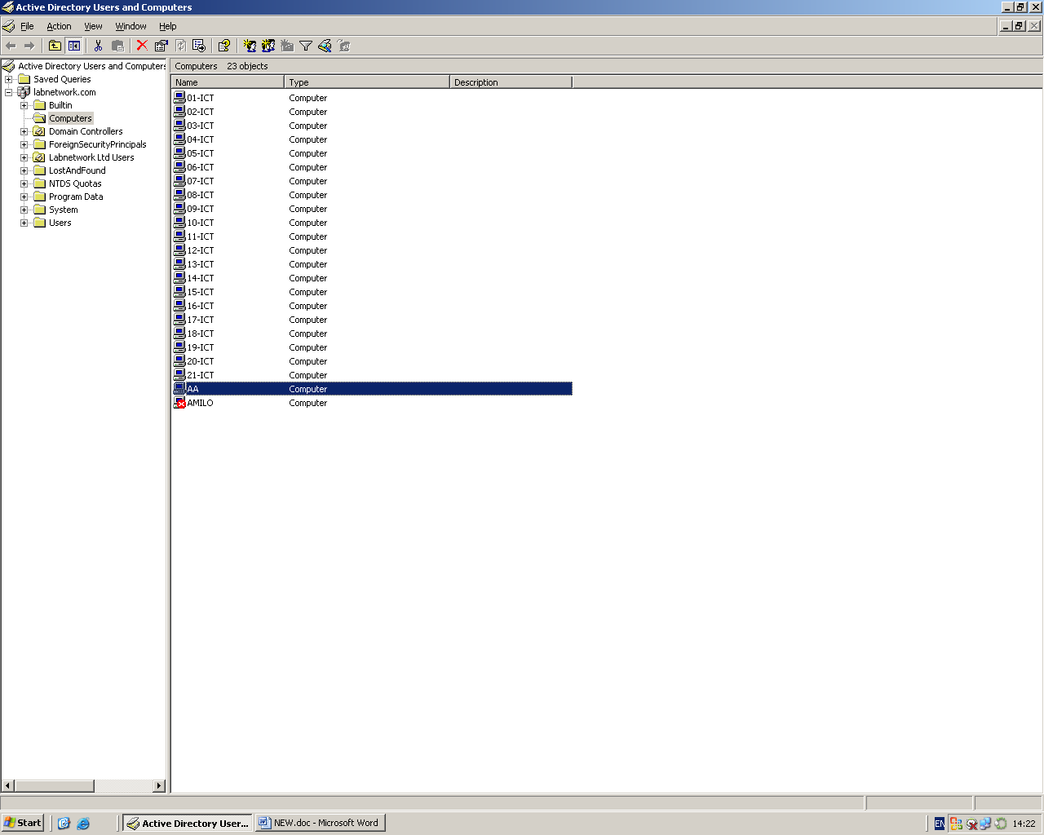

This is what fault management is used for. To detect any faults within the system. If any problem has happened within the system, they will be a red cross to tell the user that something is wrong with it. As you can see, ‘AMILO’ needs attention; it may have a problem with it. If there is no problem with the user, they will be no crosses with it.

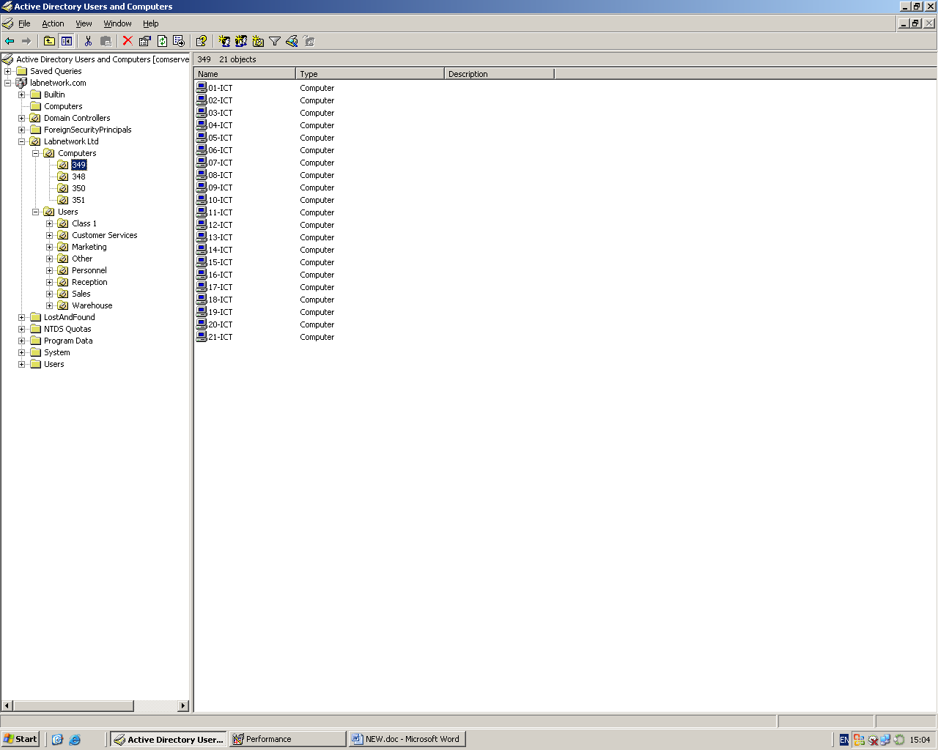**Configuration:**

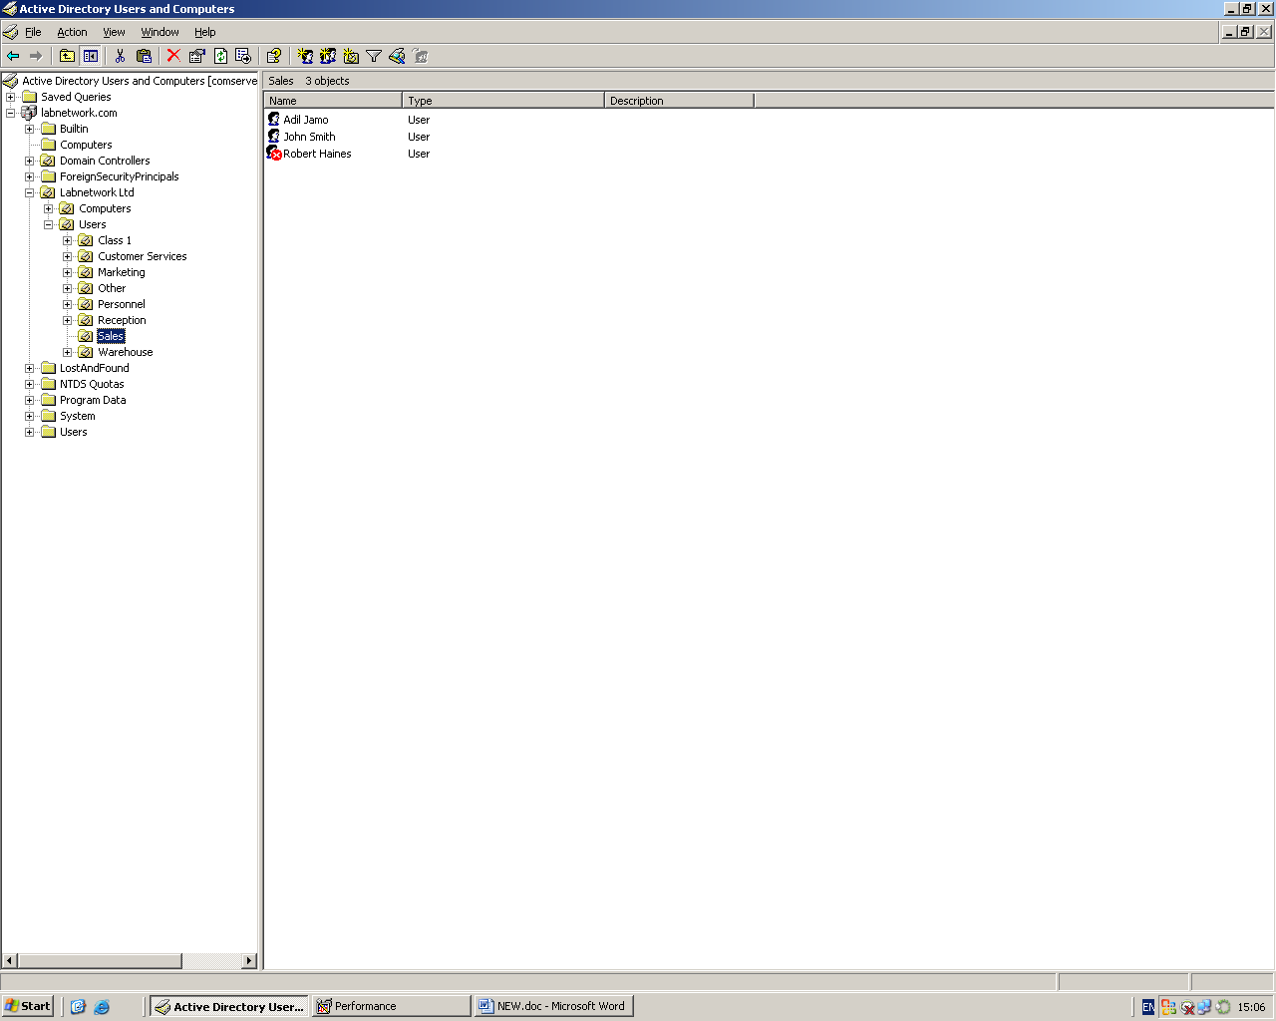This screenshot dump shows the layout and configuration of all the computers, according to the room name. Configuration is important for any network. To organise it is important, because if any problem is occurred, and the user has been told to sort the problem out, they can check on this if there is a problem. However, if it is not configured, it will be a problem. As you can see, folders are used to separate each class. Every class has been named for it not to be a problem. No matter how many computers are within the computer, they will be named for each class.

Sales Department staff is highlighted. The server is alerting staff that the user: Robert Haines has a fault on his profile or is blocked thus may need attention. This is important, as it shows who’s account has been blocked. This is for staff, so if it has been blocked, the technician can deal with it by unlocking the account.

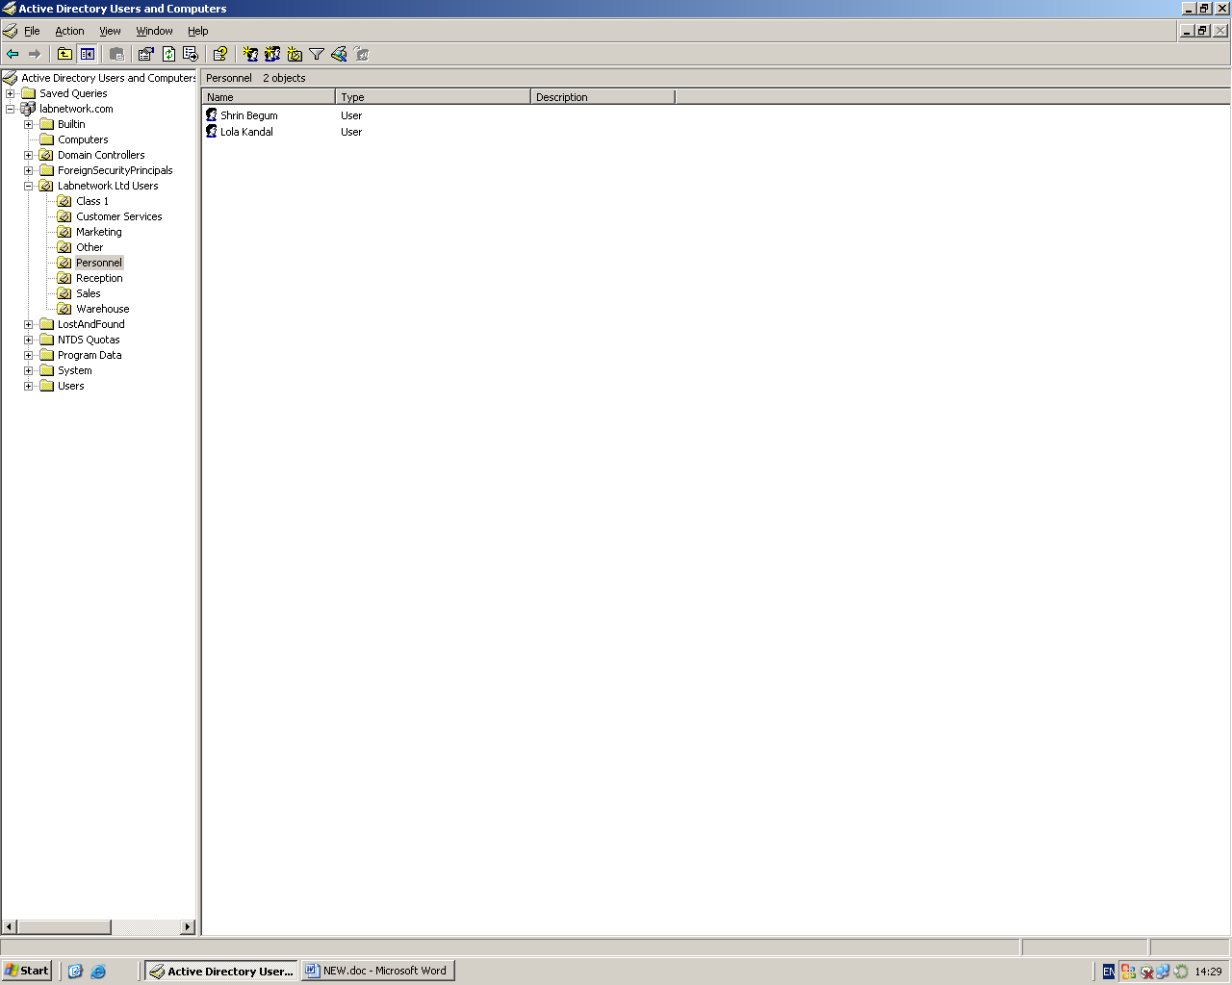

The above screen dump shows the layout and configuration of staff users, according to department. Personnel Department Staff is highlighted.

As you can see, everything that is needed is configured. This is important; without it, it will be lost.

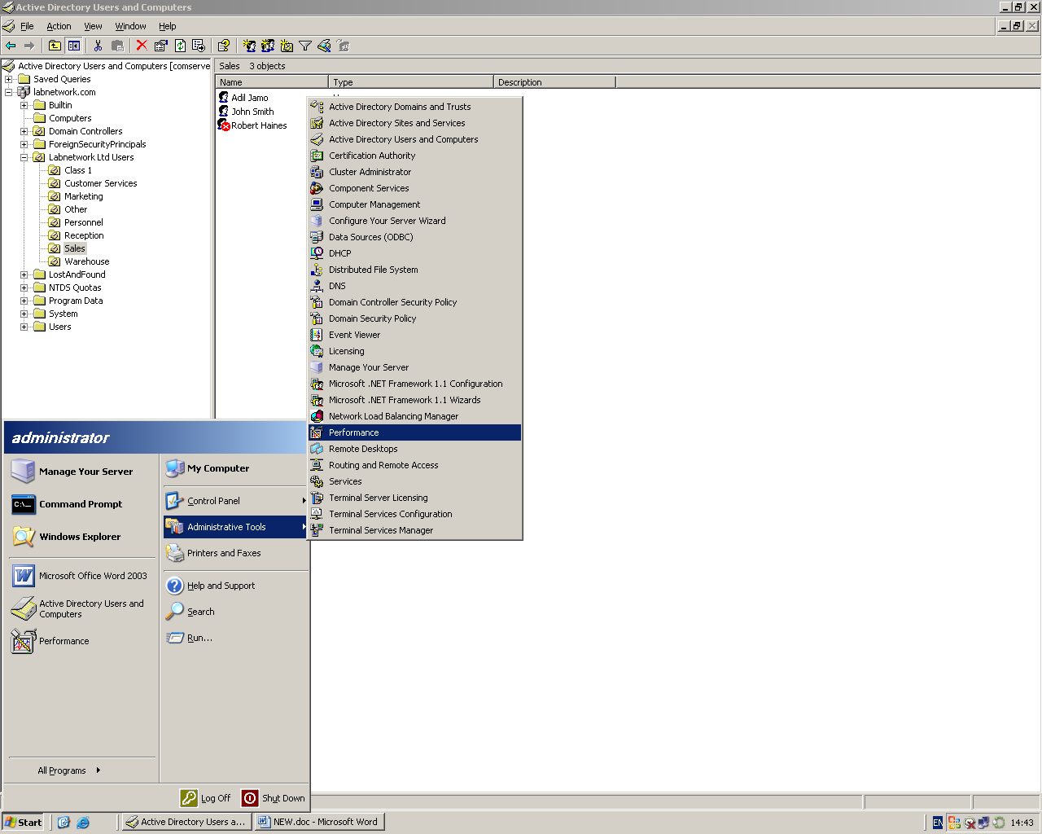**Performance Management:**

To get to this screen, you need to be the admin to get these tools. If you are admin, go on ‘start’ to ‘administrative tools’, and then ‘performance’. Browse this for performance management.

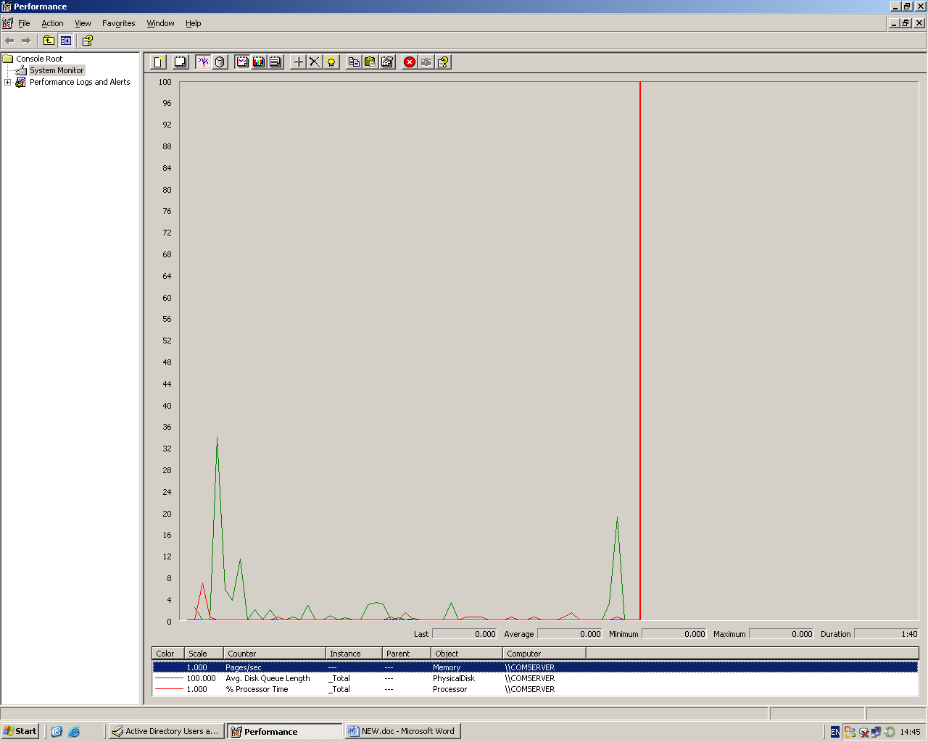Below shows performance management shows if the memory, disk space, and processor are all seem to be working fine. All seems to be working as normal. However, if there were a big line, then it would be highlighted.

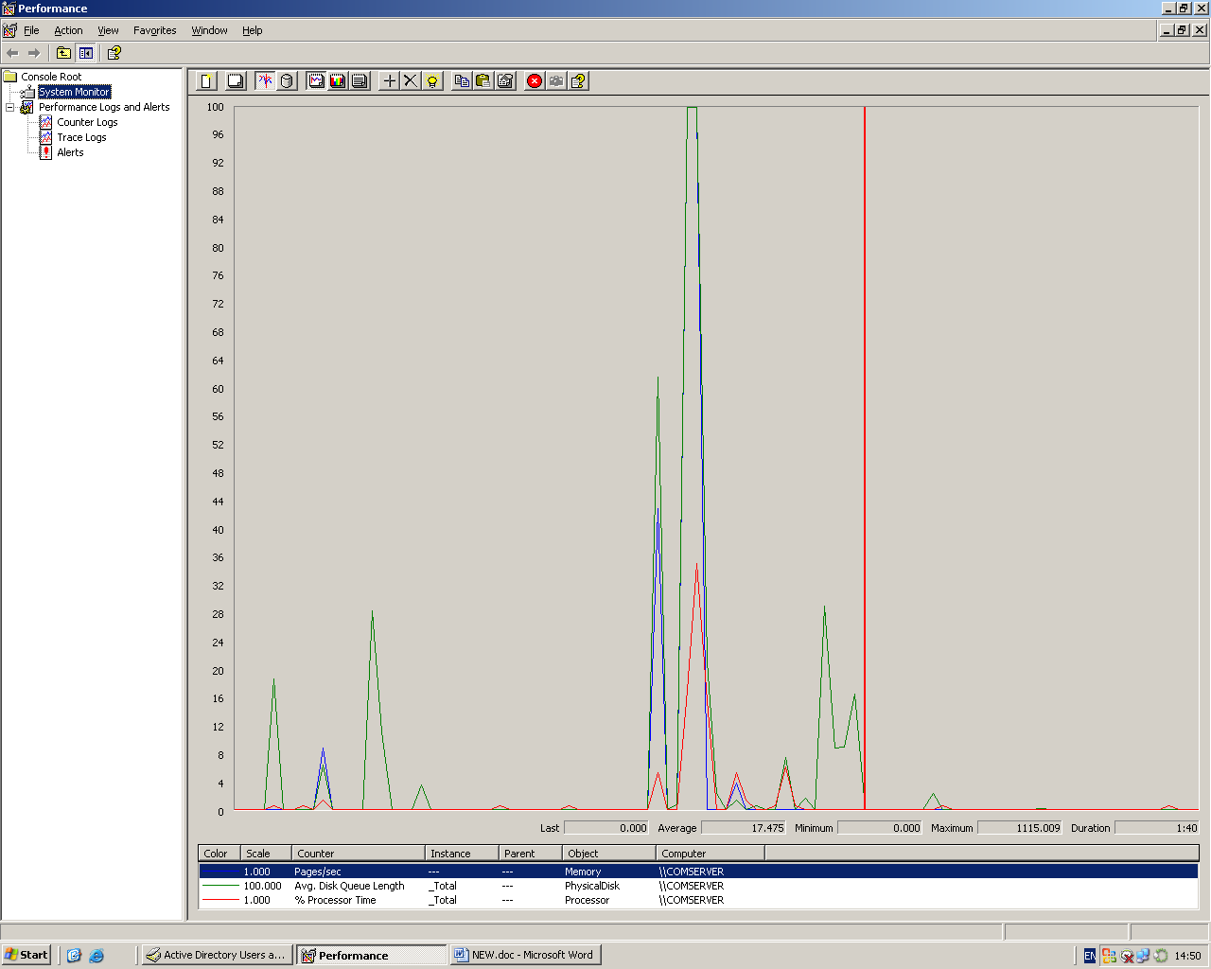

Performance Management shows examples of Memory and Processor used extensively. To maintain optimum performance of the network, you will need additional memory and faster processor as the spikes are reaching near full use up to 100%. It shows if it is running fine, or it is full. The spikes are high enough to show that it is full.

**Security**

**-Password**

Passwords is a set of characters (any on the keyboard) that needs approval to gain access to the users resources. A password for a social networking site is compulsory because you need a password to gain access. A password could be set on many sites and accounts such as:

* Users account for a PC
* Any social networking site e.g. Facebook
* Smartphones
* Tablets

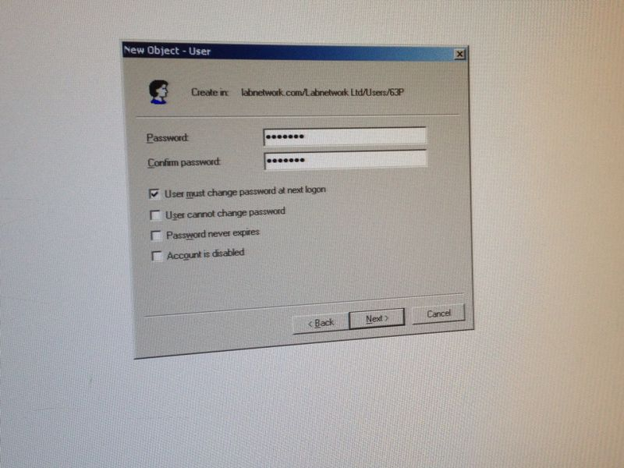The advantages for using a password is that if any other user tries getting access to your account, a password is required. If the user does not know the password, he/she cannot get access to your account. However, if you keep a simple password, it is highly likely that users and hackers may get access to your account and delete the files. Another disadvantage is that you need to remember the password. If you do no not remember the password, you cannot get access to your account. It is advisable that the user keeps a password that he will remember.